Management of Economical and Structural Changes of Business in Energy-Intensive Industrial Sectors (Using the Example of the Petrochemical Industry)
35% duplication
Annotation
The petrochemical industry is one of the main branches of Russian industry development. The average growth rate of the petrochemical industry in 2016-2018 was higher than in the manufacturing sector-about 5%; in 2019, it was 2.7%. The growth of production due to the high level of demand for the products of petrochemical enterprises determines the same characteristic of their investment activity. The desire of Russian petrochemical companies to develop the production of high-value products, economic analysis of production, structural analysis of production, availability of raw materials, assessment of energy intensity and competitiveness of existing technologies is extremely important. In this regard, the article is devoted to the management of structural changes in the business in the petrochemical industry. Recently, an analysis of average electricity consumption by petrochemical enterprises in Russia and abroad shows that enterprises lag far behind, although foreign enterprises produce slightly more than Russian enterprises in terms of production volumes. The main reason for the desire of enterprises to restructure are, of course, unsatisfactory values of financial indicators, there is also a shortage of working capital, large amounts of accounts payable, operating costs. In the process of enterprise restructuring, it is increasingly planned to create gas and petrochemical conglomerates-clusters that form the basis for the development of production; the production chain will be implemented from the production of hydrocarbons to the production of consumer goods.
Keywords: business structure, petrochemical products, oil, gas, product competitiveness, energy intensity of production, the enterprise energy efficiency.

Introduction
The Russian Federation has the largest hydrocarbon reserves, producing approximately 10% of the world's oil and gas. In 2019, oil and gas condensate production amounted to 687.4 m (million) t (tonnes = 1000 kg – translator’s note), more than half of which was directed to refining. It is worth noting that more than 40% of associated petroleum gas is processed at Russian plants. Production of petrochemical raw materials has reached more than 60 mt, these indicators exceed the needs of the entire petrochemical industry. One of the main advantages of the Russian petrochemical industry is the low cost of raw materials which is provided by both tax and customs subsidies. Transportation and its cost are also important; transportation rates are high due to the use of special containers that must meet all fire and explosion-proof requirements. As for the transportation of such bulk polymer materials as polyethylene or polypropylene, it is much safer and cheaper. Enterprises engaged in the production of petrochemical raw materials in the region that produce these products should enjoy this advantage.
It is clear that the transport component has an impact on the products produced by petrochemical enterprises: depending on the distance from the sales market, enterprises choose an economically attractive solid product.
Enterprises of the petrochemical industry diversify their production by including such activities as oil and gas production and processing, developing into large vertically and horizontally integrated structures.

Methods
The algorithm of the outlined research is presented by the following chain: concepts of the petrochemical industry - structural changes in business - problems and prospects of change management at petrochemical enterprises - improvement of the processes management of reducing the petrochemical production energy intensity.

Results and Discussion
Oil and gas production in the Russian Federation is the leading in the world, as there are huge reserves of hydrocarbons. The petrochemical industry is able to use these advantages effectively economically occupying only 1.5% of the economy.
Pyrolysis plants that were formed more than 50 years ago and have been modernized serve as the production base of the petrochemical industry. The total production capacity of Russian companies for ethylene is slightly more than 3 m t per year (less than 2% of the world). For comparison, in countries that are much more modestly provided with petrochemical raw materials, the total capacity of pyrolysis plants is many times greater. As for the pyrolysis of hydrocarbon raw materials, these are the basic petrochemical processes; the main intermediates are obtained at petrochemical enterprises - olefins (ethylene, propylene), butadiene, isoprene, aromatic hydrocarbons and other products.
According to experts, an increase in the share of petrochemical production in Russia's GDP is possible if 1) new sales markets appear; 2) world prices for minerals increase [6].
In the current complex political environment between countries, it is quite problematic to enter a new market (countries such as China are promising areas, but this is still in theory).
The world market regulates the price policy for petrochemical raw materials, and in the absence of consensus among OPEC member countries, the indicator values are rapidly moving down.
The petrochemical industry is understood as an energy-intensive industry that has a high specific consumption of both electric and thermal energy. For example, in order to produce 1 tons of chemical fiber, it will take about 20,000 kW/h of electricity, as well as more than 10 tons of fuel. As for the total consumption of resources, the indicators in oil and gas chemistry make up 20% of industrial consumption. These indicators, unfortunately, can be considered inflated.
Petrochemical plants usually use sources of cheap electricity which, in turn, helps to increase efficiency, intra- and inter-industry communication between petrochemical enterprises, allowing them to provide various combinations of production and implement effective technologies.
It is important to emphasize the high consumption of water resources in oil and gas chemistry, which are spent on washing and cooling production units, minimizing water. The total consumption of petrochemical enterprises in relation to other enterprises in Russia, of course, takes a leading place, which is a disadvantage. In order to produce 1 t of fiber, it is necessary to spend up to 5,000 cubic meters of water, the cost of producing a water-intensive unit of production is 20%.
The comparison of average electricity consumption by petrochemical enterprises in Russia and abroad (for example, in the United States), shown in figure 1, reflects a significant lag in Russian consumers. As for the volume of products produced by enterprises of the petrochemical industry, US enterprises produce only 1.21 times more than Russian ones which are a slight advantage compared to the resources spent. In this case, the business structure of Russian enterprises is the most rational.

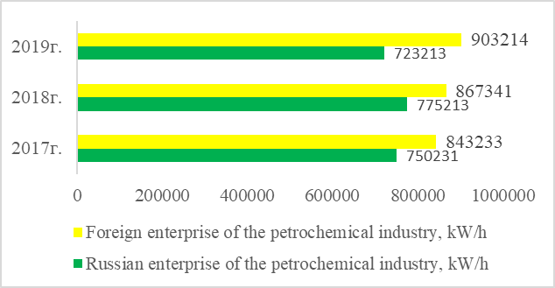
Fig.1. Average electricity consumption by petrochemical enterprises in Russia and abroad (using the example of the USA) [6].

A similar situation is observed in the area of kerosene consumption (see Fig.2.)

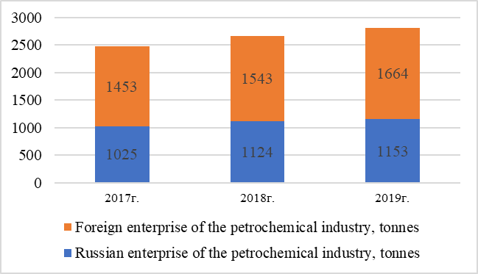
Fig. 2. Average indicators of kerosene consumption by enterprises of oil and gas chemistry [10].

The formation of territories where enterprises for the production of plastics and synthetic resins were located took place both in the Central region of Russia and in the Volga-Vyatka region. The enterprises were mainly provided with imported raw materials. At the moment, due to the expansion of the field of application of hydrocarbon petrochemical raw materials, there is a territorial dispersion of enterprises throughout Russia. For example, there are enterprises observed in the area of oil refining, oil production and on the oil and gas pipeline routes: Volga region (Volgograd and Kazan), Ural region (Ufa and Nizhny Tagil), Central region (Moscow and Ryazan), Northwest region (Saint-Petersburg) [7].
The volume of oil and gas condensate production in Russia is shown in Fig.3.

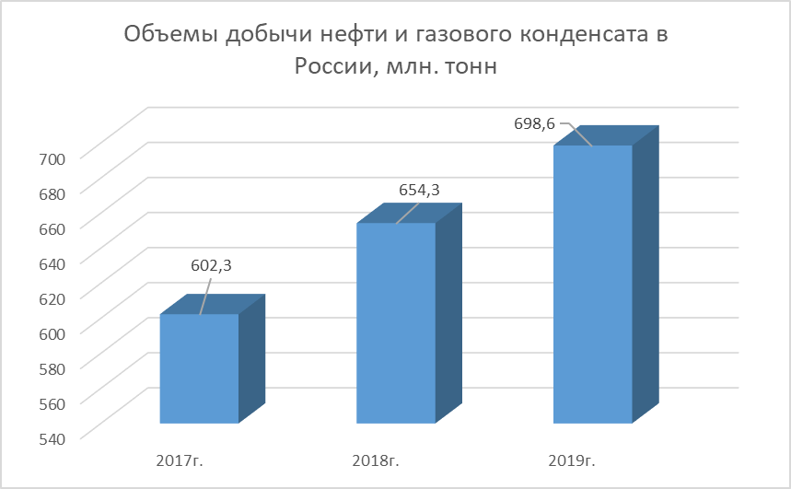
Fig. 3. Oil and gas condensate production volumes in Russia, million tonnes [10].

The data in Figure 3 reflect the annual growth in oil and gas condensate production, which totaled 698.6 m t in 2019. The financial condition of the industry enterprises is characterized by high indicators of profitability of production and consistently generated positive cash flows from operating activities. High indicators of financial and economic efficiency of petrochemical enterprises are determined by the customs aspect (subsidies), and pricing policy (import parity between price and transportation) in the case of deliveries to the domestic market [11].
The largest petrochemical structures in Russia are: TAIF Group of Companies, Rosneft, LUKOIL, Gazprom, Nizhnekamskneftekhim, SIBUR Holding, the main business models of companies are shown in Fig.4.

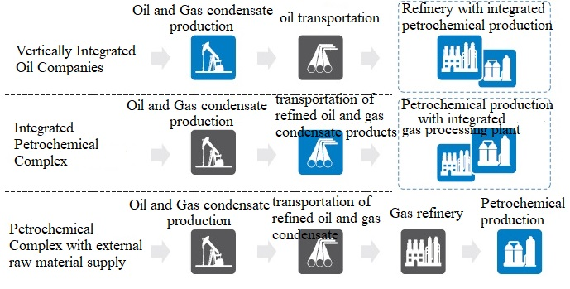
Fig. 4. The basic business model of a petrochemical companies of the Russian Federation

An important feature of the business models of the companies described is long-term guaranteed deliveries, since the oil and gas transportation infrastructure is considered very developed, an important point is the location of production facilities near pyrolysis plants [10].
In modern conditions in the petrochemical industry, there are cases of enterprise restructuring - changes in the structure of the enterprise (the location of elements), as well as elements that form the business, taking into account the influence of factors both external and internal environment. The restructuring includes:
- Measures to improve the management system;
- Measures to improve financial and economic policy;
- Measures to improve marketing communications and sales channels;
- Measures to improve personnel management.
The main reason for the desire of enterprises to restructure is the low efficiency of their activities, which is expressed in unsatisfactory values of financial indicators, a lack of working capital, a high level of receivables and payables, and operating costs.Over the past five years, as part of the restructuring of enterprises, it was planned to create special large gas and petrochemical conglomerates - clusters that would solve one of the key structural tasks - the formation of a base for the development of production.
In each cluster, it was planned to implement the production chain (starting with the production of hydrocarbons and ending with the production of final consumer goods). In accordance with international experience in creating clusters, this strategy was analyzed and approved.
The main advantages of the production organization are the reduction of operational logistics costs and the possibility of using a large-scale effect. The benefits of creating this infrastructure, as well as various types of petrochemical products, consist in the concentration of a large number of industries [6].
Petrochemical companies have announced projects for the production of olefins, which are central to the cluster. The total combined annual production capacity of ethylene was 7.8 m t in 2017, and by 2022 this figure was planned to reach 12.8 m t. Peripheral enterprises included in the cluster were small and medium-sized enterprises focused on the production of final consumer products. It was also planned to create a management company (a special organizational structure), its main objectives were to ease joining the cluster of new enterprises, as well as to accompany implementation of logistics issues [3].
Ultimately, this implementation would reduce the deficit of production capacity, improve domestic demand for petrochemical products, and stimulate exports.
It should be noted that in modern conditions clusters are not introduced: these projects are either postponed to a later date, or canceled altogether (Fig.5).

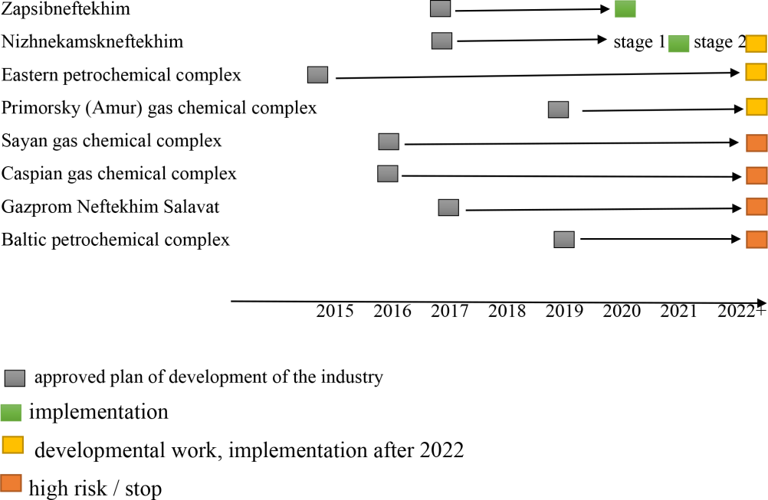
Fig.5. Status of pyrolysis plant construction projects up to 2030 [7].

The key problem encountered in the implementation of investment plans was the problem of providing raw materials and developing transport infrastructure, which is extremely capital-intensive and makes the project implementation process financially more difficult.
Despite this, investment processes in individual enterprises are being implemented, so in the period up to 2025, it is planned that the ethylene capacity will grow by more than 2.1 mt, propylene - by 1 mt.
In 2019, ZapSibNeftekhim was commissioned with a capacity of 1.5 mt of ethylene and 500,000 t of propylene per year. In addition, the production of olefin will increase at the existing facilities of SIBUR (Fekhtin 2019).
The expansion of paraxylene capacity is focused on the introduction of new capacity for Terephthalic Acid (TPA), which is currently in short supply. In addition to the growing volume of PET production, additional demand for TPA was provided by the new production of the Plasticizer Dioctyl Terephthalate (DOTP, 100,000 t per year), launched at SIBUR-Khimprom in early 2019. SIBUR will complete the modernization of TPA production at the Blagoveshchensk Polyef production site, which will increase capacity from 270 to 350 thousand tonnes.
The stagnation of the Russian economy, combined with energy intensity and a lack of sources of investment in expanding the production capacity of enterprises in the petrochemical sector of the economy, may threaten Russia's ability to serve export markets. Indonesia and the United Kingdom provide examples of how the economic situation in the industry has affected the transformation of the country's position from a net exporter of oil and gas to a net importer. Countries such as Mexico and Iran are expected to follow this path.
Despite the significant raw material potential of Russia, its implementation can be ensured by the flow of investment and technological capital. Projects aimed at improving energy efficiency and returns from the activities of petrochemical enterprises are seen as economically justified in terms of investment volumes and payback periods [9]. In the face of limited production capacity and increased demand, reducing energy intensity will be a key factor in ensuring adequate supply [5].
The institutional system of the industry already uses mechanisms to encourage investment in technologies that improve the efficiency of petrochemical raw materials and gas production (for example, incentives for gas production from deep horizons rich in gas condensate). One of them is the technology of Cycling, which allows you to extract valuable components from the fat gas, and the dry gas is pumped back into the reservoir, providing reservoir pressure.
In addition, measures to improve the efficiency of the use of energy resources of enterprises of the petrochemical complex should include:
- Unity of the methodology of the energy saving process in order to introduce unified regulations and rules in the petrochemical industry;
- The use of modern methods for determining the potential (Pinch Analysis, Life-cycle cost analysis (LCCA), Exergy Analysis). Pinch Analysis refers to the minimization of energy consumption of various chemical processes by calculating the minimum energy consumption; LCC Analysis refers to the method of estimating costs over the entire life span; Exergy Analysis refers to the thermodynamic analysis of systems interacting with the environment. These links allow you to evaluate the effectiveness of your work and determine areas for improvement;
- Implementation of automated systems for accounting and monitoring energy use.
All these aspects should occur simultaneously and continuously: initial energy consumption, formulation of a feasible goal, methodological and expert support, exchange of knowledge and experience.

Summary
Structural changes in the activities of petrochemical enterprises are expressed in the institutional features of the organization of the business model, which determines the level of production diversification and product differentiation of the business. The need to improve approaches to business organization in this sector of the economy, in addition to the natural desire to improve the financial results of management, is associated with the goal of improving the energy efficiency of domestic production, which has been declared at the Federal level. Meeting the goal under the conditions of significant energy intensity of industry enterprises is mediated by investment activity of enterprises in the direction of improvement of technologies and modernization of production facilities most of which was built in 80-ies of the last century. In these conditions, financial assistance will help enterprises in the petrochemical industry to implement state tasks, coordinate actions with the development strategy of related industries, create conditions for stimulating production development, and make choices for raw materials and products with an understanding of the market.

Conclusions
The financial condition of the industry enterprises is characterized by high indicators of profitability of production and consistently generated positive cash flows from operating activities. The analysis of measures to improve the efficiency of energy use of petrochemical enterprises has allowed to reveal a complex of them: energy conservation with a view to implementation in the petrochemical industry common provisions regulations; the use of modern methods of determining capacity; the introduction of automated systems of accounting and monitoring of energy use.

Acknowledgements
The work is performed according to the Russian Government Program of Competitive Growth of Kazan Federal University.

References
- Akerlof, G.A. (2016). The Market for “Lemons”: Quality Uncertainty and the Market Mechanism. The Quarterly J. of Economics 84.
- Dahlman, C. J. (1979). The problem of externality. The journal of law and economics 22(1), pp. 141-162.
- Fekhtin, A.L. (2019). Petrochemical Processes: Textbook. A.L. Fekhtin. – Moscow: Mir, – 541 p.
- Frank, E. V., Oksana, V. M., & Lilia, V. E. (2016). Innovational mechanism of implementation of cluster initiatives in business. European Research Studies Journal, pp. 179-190.
- Gabdullina, G.K., & Khaziakhmetova, G.A. (2013). Analysis of the Development and Evaluation of the Economic Feasibility of Merging Holdings (on the example of the entry of JSC Nizhnekamskshina into TATNEFT Group of Companies). Bulletin of ChSU 1, pp. 236-242.
- Obukhov, I.M. (2019). The State of the Petrochemical Industry Under Sanctions: Textbook.– Moscow: Eksmo, – 412 p.
- Reshetnikova, A.I. (2019). “Petrochemical Structures of Russia: Textbook.”– Moscow: Drofa, – 441 p.
- Robinson, A. (2017). The Problem of Management and the Size of Firms. Economic Journal, pp. 240-254.
- Shcherbakov, M.P. (2018). Stimulating the Production of Petrochemical Raw Materials: Textbook.– L.: Mir, – 421 p.
- Starkov, A.E. (2019). Gas Processing Capacities: Textbook. – M.: Drofa, – 228 p.
- Stepanov, V.A. (2019). Petrochemical Industry: Textbook.– L.: Mir, – 347 p.
- Williamson, O.E. (2018). Markets and Ierarchies: Analysis and Antitrust Implications, р.65.

Khaziakhmetova Guzel azatovna graduated from the Moscow Institute of Humanities and Economics in 1998 with a degree in Management. in 2006, she successfully defended her dissertation on "Extended reproduction of intellectual property in joint-stock corporations". Author of more than sixty publications on human capital management, economic assessment of the effectiveness of organizations, analysis and evaluation of investment performance. He is a practicing specialist in the field of diagnostics and optimization of business processes of the organization. The experience of scientific and pedagogical activity is more than 18 years.

